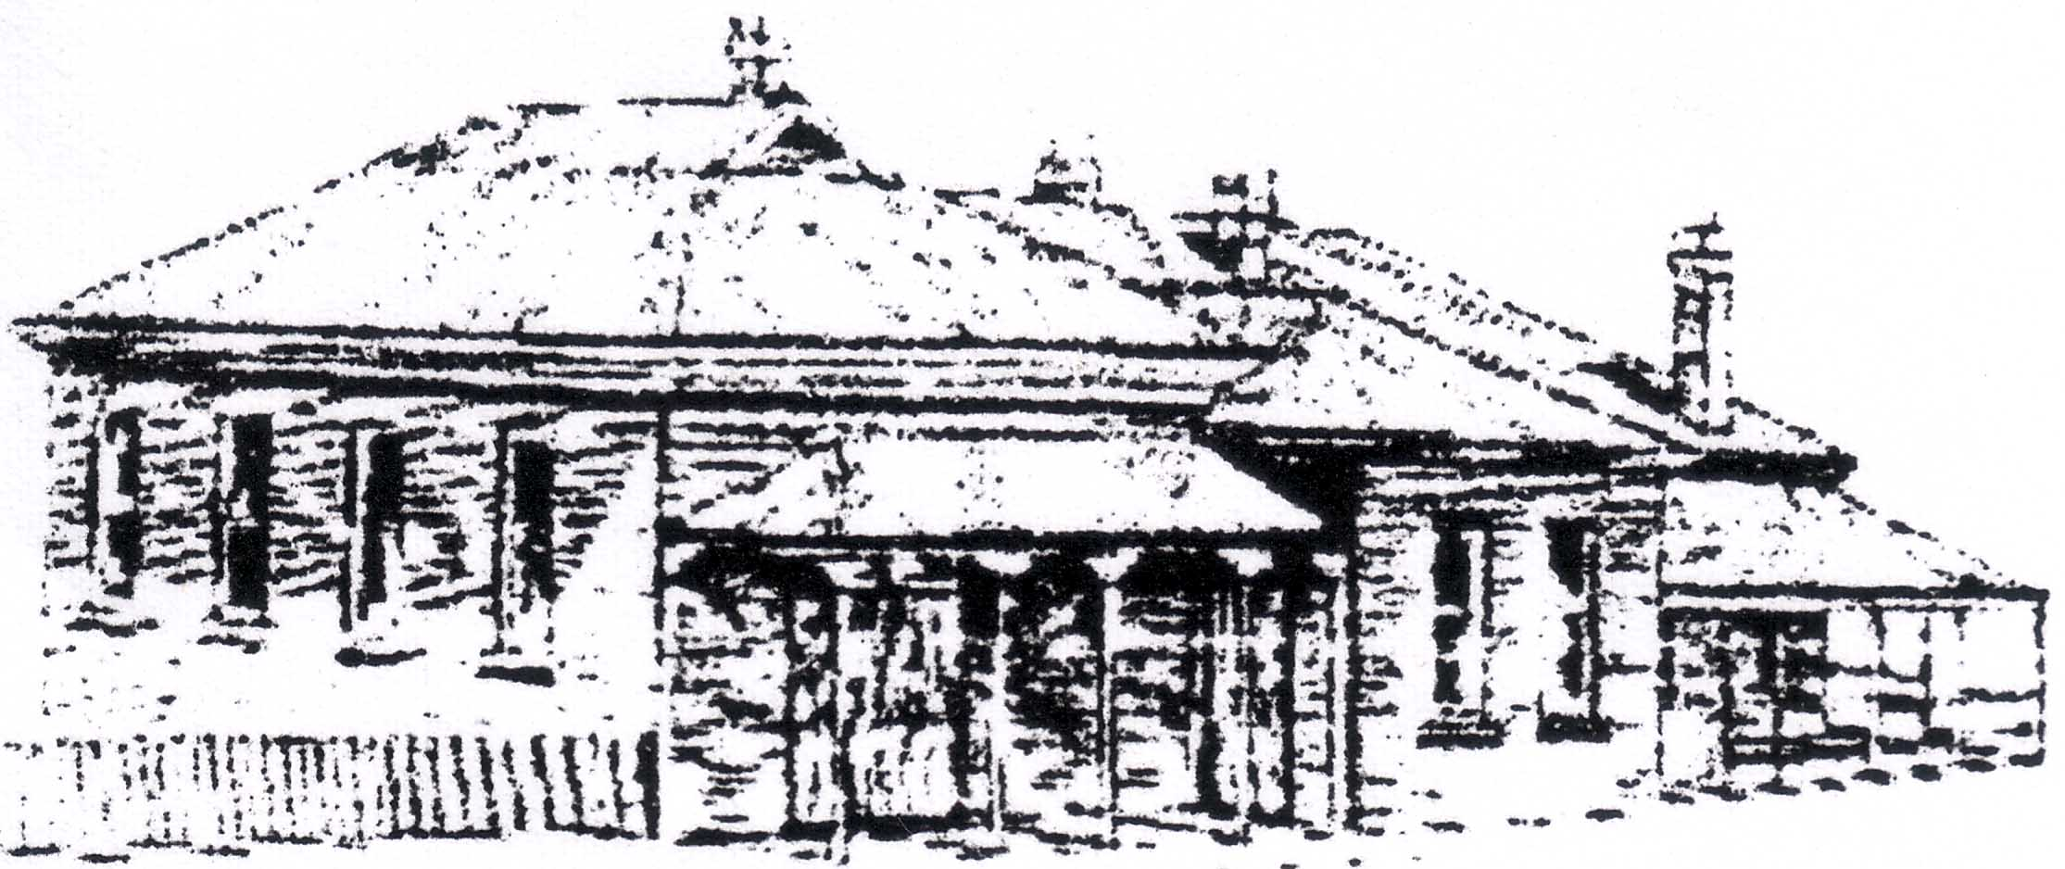
BEGA VALLEY GENEALOGY SOCIETY INC.

Post Office Box 19

Pambula NSW 2549

ABN: 65 840 343 603

APPLICATION FOR MEMBERSHIP

Mr/Mrs/Ms. … … … … … … … … … … … … … … … … … … … … … … …… … … … … …
Surname Christian Name
Address: . … … … … … … … … … … … … … Town:… … … … … … … … … …. …
Post Code : … … … . … … … … … … … … … Home Telephone …… … … … … …
Email : … … … … … … … … … … … … … … … … … … … … … … … … … … … … … … … .

Signed: … … … … … … … … … … … … Date : … … … … … … … … … … … … … ….

Joining Fee $ 10.00

Office use only
Cheque / Cash /EFT … … …
Receipt No. … … …
Membership No. … … …
Membership Register … … …
Journal Register … … …
Card … … …
Single $45.00. … … …
Family (2 Adults) $60.00 … … …
Pensioner Family ( 2 Adults) $45.00 … … …
Pensioner & Students $35.00 … … …
Outside Bega Valley Shire $35.00 … … …
Outside Bega Valley Shire
Family ( 2 Adults) $45.00 … … …
Corporate Membership $60.00 … … …
. .
Donations :
.All donations are greatly appreciated … … … See below DGR section

Total … … …
Memberships can be paid by EFT or Direct Deposit.
Bank: Pambula Community Bank Branch of Bendigo Bank Ltd. Pambula
Name: Bega Valley Genealogy Society Inc.
BSB: 633 – 108 Account: 141 000307
Ref: Your Name (example: ELizabeth McIntyre)

NOTE: Our Journal ‘The Valley Genealogist’ is emailed Feb, Jun & Oct each year, as a PDF.

LIBRARY ROSTER
We are always looking for Library Volunteers, would you like to be trained as a
Library Volunteer, in due course? YES / NO
Please Note: New Membership Cards & Receipts will be emailed, otherwise membership cards can be collected from our main research room.

Deductible Gift Recipient (DGR) Status

The Bega Valley Genealogy Society Library Fund is registered with the ATO as a DGR
all donations over $2 are Tax Deductible.

MEMBERS INTEREST INDEX

Please complete this form if you wish your personal and family research details to be
entered in the index and published. Note this will be on display in the premises.

In the future this information will be published in our BVGS website, do you have objections to this? YES / NO

YOUR NAME AND ADDRESS Membership No. … … …

… … … … … … … … … … … … … … … … … … … … … … … … … … … … … …

… … … … … … … … … … … … … … … … … … … … … … … …… … … … … … …
Surname County/State
Parish Town/Village Century

Notes (eg Christian Names, Occupation)

Surname County/State
Parish Town/Village Century

Notes (eg Christian Names, Occupation)

Surname County/State
Parish Town/Village Century

Notes (eg Christian Names, Occupation)

Surname County/State
Parish Town/Village Century

Notes (eg Christian Names, Occupation)

Surname County/State
Parish Town/Village Century

Notes (eg Christian Names, Occupation)

